 **Review - 1**

**Team – A9**

**USN:** 02FE21BEC005 – AKSHAY NAIK

**USN:** 02FE21BEC014 – ARPITA KULKARNI

**USN:** 02FE22BEC044 – LAXMI KAMMAR

**Topic:**

**Write a C code to demonstrate the concept of Task Switching** a. 1st Task – Stepper motor clockwise

b. 2nd Task – Blink LED with delay of 2sec.

Under The Guidance Of:

Prof. Vidyadhar Dodamani Guide Signature

A5

• **Code:**

#include<rtl.h>

#include<lpc21xx.h>

#include<stdio.h>

void delay(unsigned int);

void led(void);

OS_TID tsk1,tsk2;

int i;

__task void job1(void);

__task void job2(void);

__task void job1(void)

{

os_tsk_prio_self(1);

os_tsk_create(job2,0);

PINSEL0=0x00000000;

IODIR0=0x0000F000;

while(1)

{

IOSET0=0x00008000;

delay(65000);

IOCLR0=0x00008000;

IOSET0=0x00004000;

delay(65000);

IOCLR0=0x00004000;

IOSET0=0x00002000;

delay(65000);

IOCLR0=0x00002000;

IOSET0=0x00001000;

delay(65000);

IOCLR0=0x00001000;

}

}

__task void job2(void)

{

os_tsk_prio_self(2);

while(1)

{

led();

}

}

int main(void)

{

os_sys_init(job1);

while(1);

}

void delay(unsigned int j)

{

unsigned int i;

A5

for(i=0;i<=j;i++);

}

void led(void)

{

IODIR0=0xFFFFFFFF;

while(1)

{

IOSET0=0x00FF0000;

delay(2500000);

IOCLR0=0x00FF0000;

delay(2500000);

}

}

• **System And Thread Viewer:**

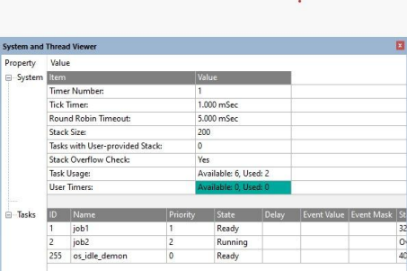A5

**OUTPUT**

A5